User Manual

PROJECT TITLE : CSIRO

SQUAD 1
SUPERVISOR : ARKADY ZASLAVSKY

Contents
1.1 Project Goal 4
1.2 Description 5
1) checkOntologyConnection (URL, API KEY); 16
2) getAllOntologyNames() 17
3) getTextDefinitions (URL, API KEY, Text string, Ontologies, Match longest, Partial word matching, Include mapping, Exclude Numbers, Exclude Synonyms ) 17
4) insertToDataBase(Collection name, Data) 17
5) updateFromDataBase(Collection name, currentValues, newValues) 17
6) deleteFromDataBase(Collection name, Query Object) 18
7) searchFromDataBase(Collection name, Query Object) 18
8) getOntologyByID(Collection name, Query object) 18
9) disableExistingOntology(Collection name, Query object, currentValues, newValues) 18
10) enableExistingOntology(Collection name, Query object, currentValues, newValues) 18
Term Search 19
Subtree Search 19
Ontology Property Search 20
Annotator 20

- GENERAL INFORMATION

General information section explains in general terms the system and the purpose for which it is intended

Project Goal

- The main aim of project is to build a restful API which includes functionalities to connect with external vocabularies such as
- Research Vocabularies Australia
- https://vocabs.ands.org.au/
- CSIRO's Linked Data Registry
- http://registry.it.csiro.au/ etc.
- To get description to the given scientific words/ phrases and the ability to connect / add new vocabularies as the client expects.

Description
Technical documents use terminology with the intention that specific words and phrases denote more or less precise definitions of some concept. However, in many (most) cases a term has more than one definition in different vocabularies, which can differ either a little or a lot. Accurate understanding of a text can be enabled by hyperlinking all technical terms to the intended definitions.
This project will develop a tool and web micro-service to enable semi-automated annotation of a text with hyperlinks to the definitions of terminology used. The definitions should in turn be sourced from a range of vocabularies (i.e. sources of terms), accessed through ‘standard’ APIs.
There are a number of vocabulary services are available which provide definitions for technical terminology, organized into 'controlled-vocabularies', published as ‘linked data’ with both human user interfaces, and semi-standardized APIs:
Research Vocabularies Australia https://vocabs.ands.org.au/ CSIRO's Linked Data Registry http://registry.it.csiro.au/ AusGIN Geoscience Vocabularies http://www.geoscience.gov.au/datastandards NERC Vocabulary Service http://vocab.nerc.ac.uk/collection/ Bioportal https://bioportal.bioontology.org/ Library of Congress Subject Headings https://id.loc.gov/authorities/subjects.html DBpedia https://wiki.dbpedia.org/

- PROJECT ARCHITECTURE

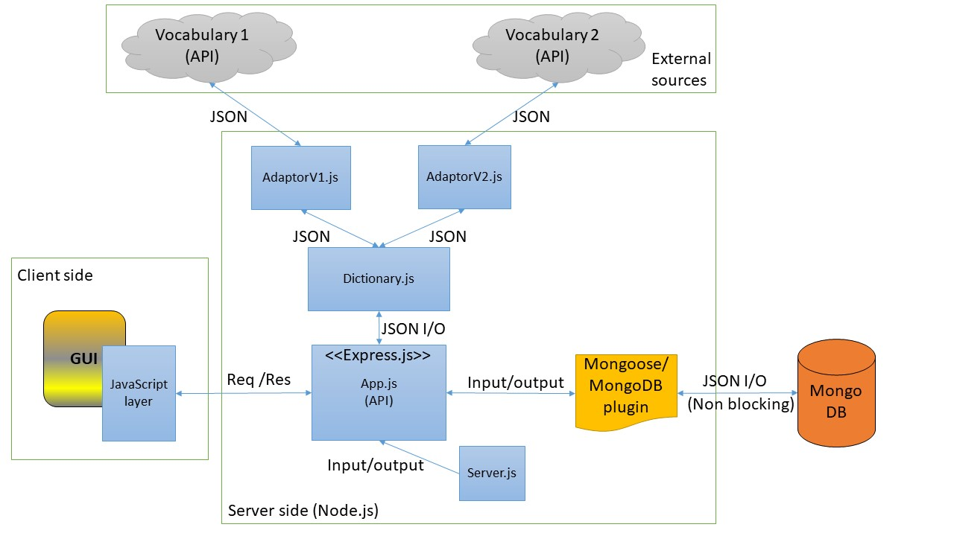

Above diagram shows the architecture of proposed web application. It consists of three main areas which are Client side, Server side and External sources. Client side is the area which consists of GUI (Graphical User Interface) and corresponding JavaScript layer to communicate with server side. As per the meaning of GUI, it will be the interface which can be seen from the client browser and it will be stacked with text fields, buttons etc. The corresponding JavaScript layer is here for the purpose of Dynamic content loading, otherwise the client page will be static and always have to reload itself. This JS layer will communicate with server side’s App.js (JavaScript file) which will be the API (Application Programming Interface) of this web application developed with Node.js’s most popular web application platform, Express.js. This file will be consisting of all the functionalities in this web app.
When client side ask a definition for a given text as a HTTP Request, App.js will automatically check in the connected (NoSQL) MongoDB database, if that request is already been responded. If it exists, the answer will be pulled out from the database. If not, it will connect with external vocabularies by using corresponding server information (Ports etc.) from the Server.js file, in order to find the answer. The response data from these vocabularies will be in the structure of JSON (Java Script Object Notation) and our application can easily handle this since it will be developed with Node.js.
In order to make connections with external sources, Dictionalry.js file and AdaptorV1.js, AdaptorV2.js files will be used. The advantage of this class structure is, if the client wants more external vocabularies to connect with this application, he can easily do it by just designing an Adaptor.js class without changing the dictionary class or any file in the system.
Upon the receiving of required result from external sources, App.js will save it in Mongo DB for future references through the Mongoose JS/MongoDBplugin. Moreover, since MongoDB is based on JSON objects, this process will be much easier to implement. After that App.js will send the HTTP response with result data to the client side’s JS layer and it will be shown in the GUI dynamically.

- PROPOSED TECHNOLOGIES

This text annotating web application will be developed by using following technologies.
- HTML/ CSS
- Bootstrap
- HTTP/HTTPS
- JavaScript/ Node.JS (JavaScript runtime)
- Express.JS (Web application platform)
- MongoDB (NoSQL database repository)

- Node.JS is ideal for this type of projects because there will be no heavy CPU calculations. Since Node.JS has a single thread to support all the client’s requests it will be a faster mechanism.
- Express.JS is the most popular web application platform of Node.JS and it is easier to build a faster API by using this technology.
- MongoDB is ideal for the database repository, since it is based on JSON objects and it’s easier to connect with Node.JS and do CRUD (Create, Read, Update and Delete) operation.

- GETTING STARTED

4.1 Installation

This project will develop a tool and web micro-service to enable semi-automated annotation of a text to the definitions of terminology used. The definitions should in turn be sourced from a range of vocabularies (i.e. sources of terms), accessed through ‘standard’ APIs. A tool to detect words or phrases within a text that have definitions from two source vocabularies which allow the user to select which definition applies to the usage of the term in the context.
A user needs to clone or download the code using Git as shown in below screenshot:

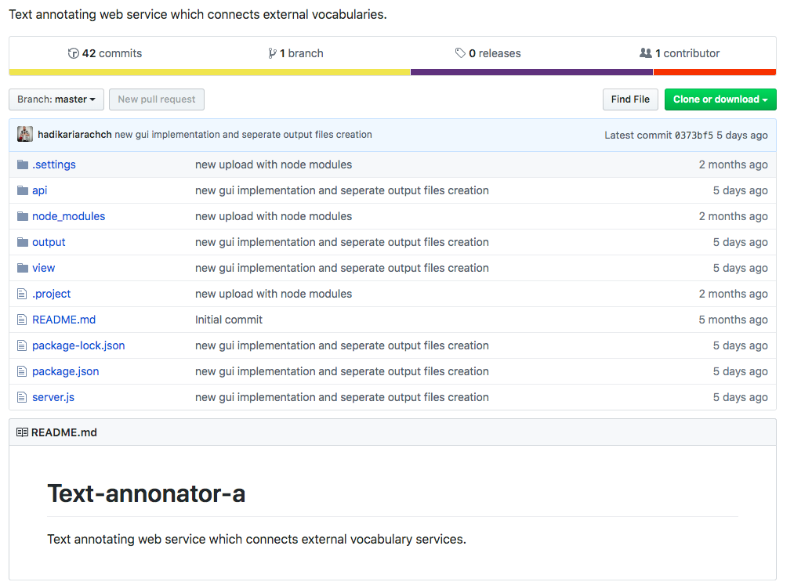

Once user has it is cloned or downloaded he has to run it in his git hub account and then open the command prompt by clicking on it.
Once the command prompt is opened type “node server.js” and press enter. After pressing enter line will be print saying “Annotator Restful API has started on: 3000 port”.

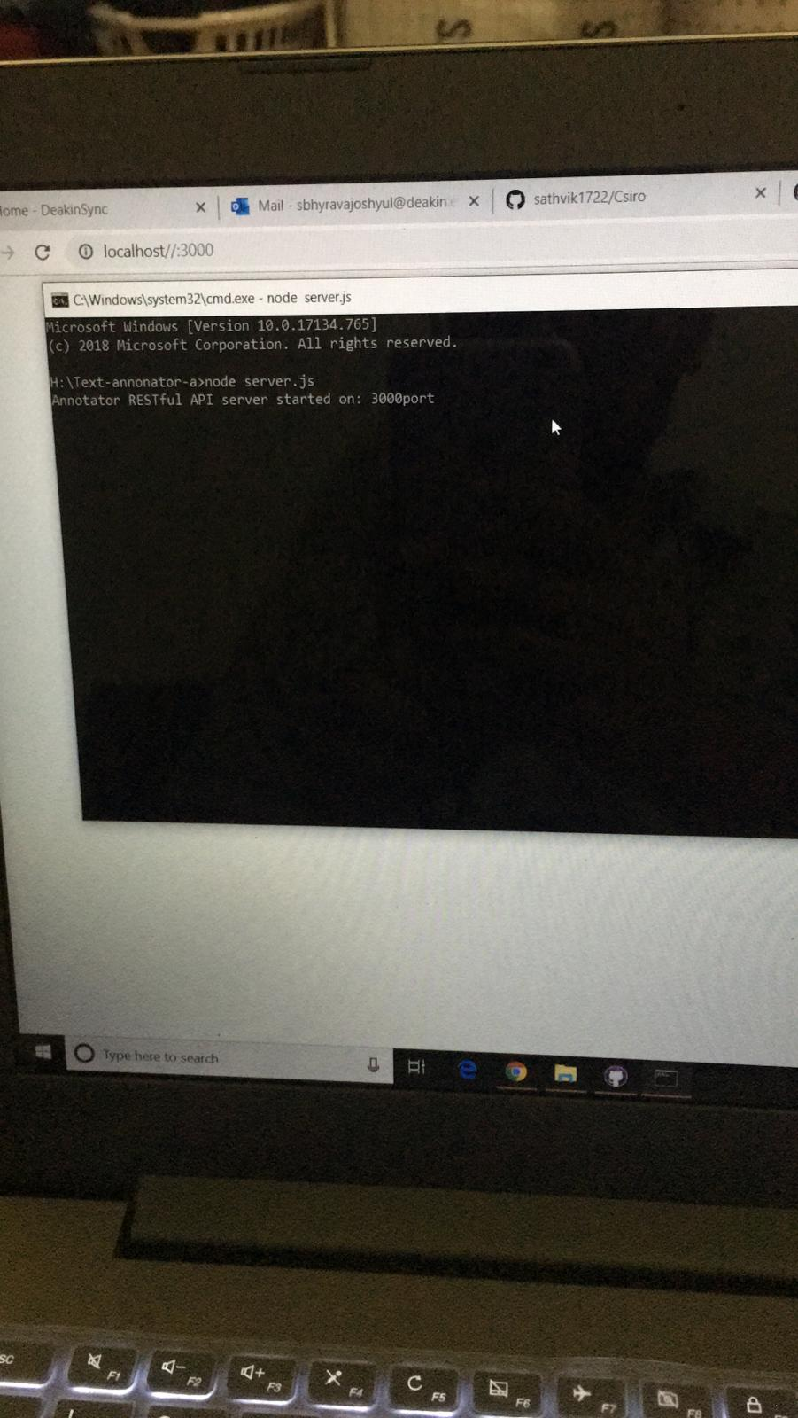

Then user can directly go to the browser and type host name as “localhost:3000”.
User will be redirected to the User interface.

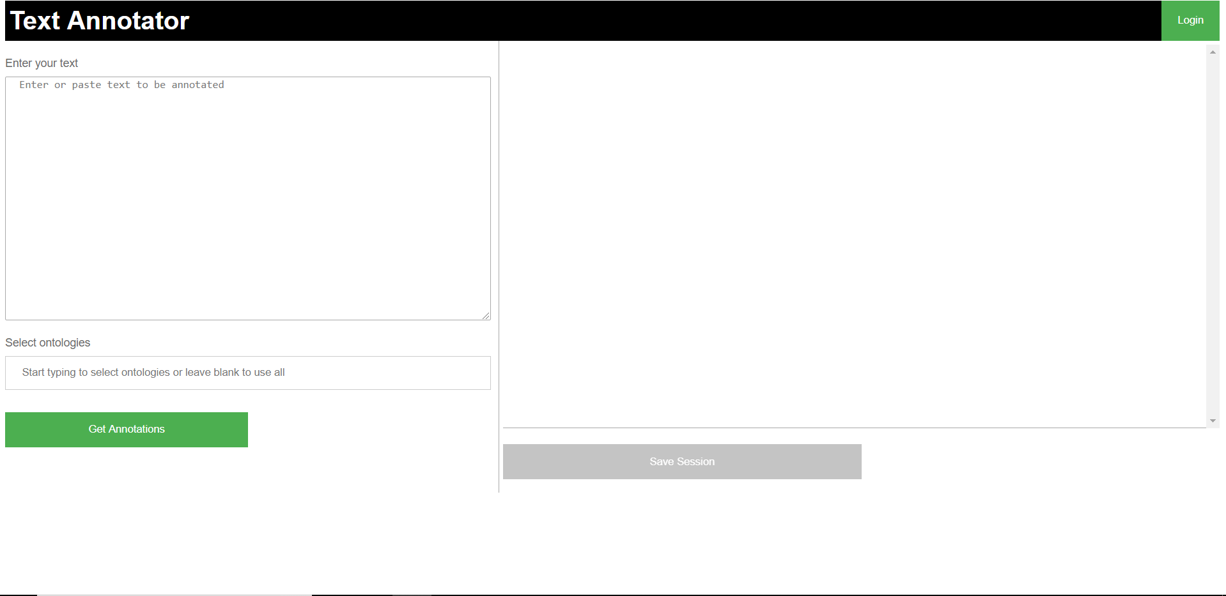

The figure above displays the outlook of the project in which it has a text box to enter a sentence or a technical word. Below is the option to select the list of the ontologies. By doing so the user can choose the definition from their required dependencies.

4.2 Test Cases

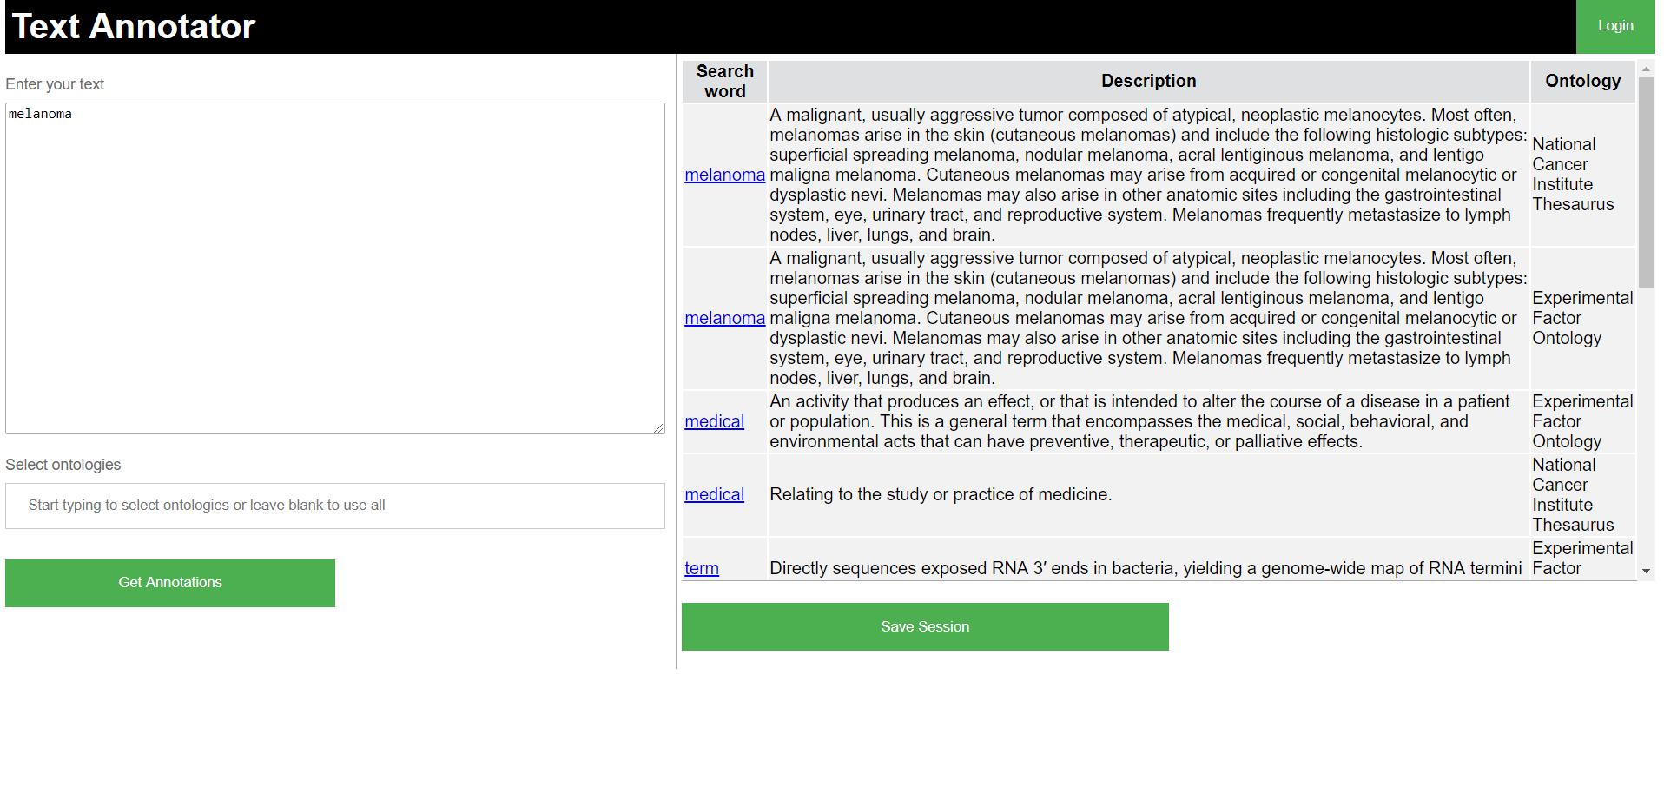

From the above figure we could see that a medical word melanoma is entered in which we can see the word description along with the ontology. We have connected two external vocabularies to find definitions for given words/phrases.

The API can be accessible using its URL, and we can give a search term for it by binding it at the end such as (“Host/annotator/search/: keyword”)

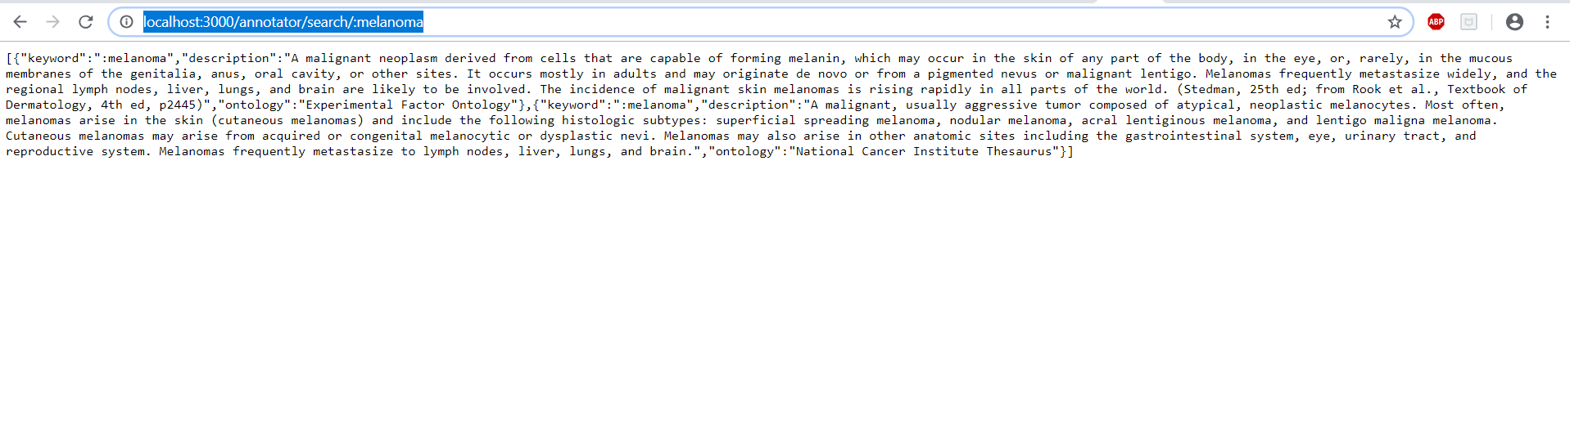
The API can show the connected external APIs as a Jason value, when you call the URL as (“Host/annotator/ontologylist”)

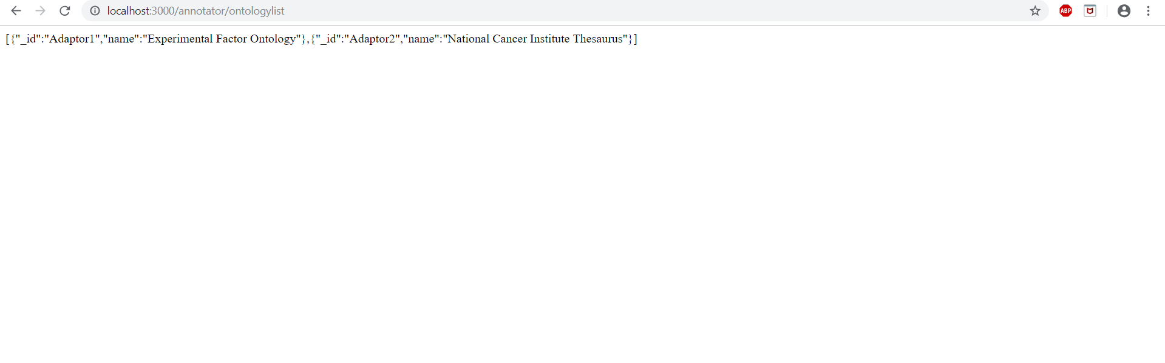

The Text Annotator can easily identify the stop words also. As You can see in the below picture It has identified the words can, the, of and be and did not show any annotations for them.

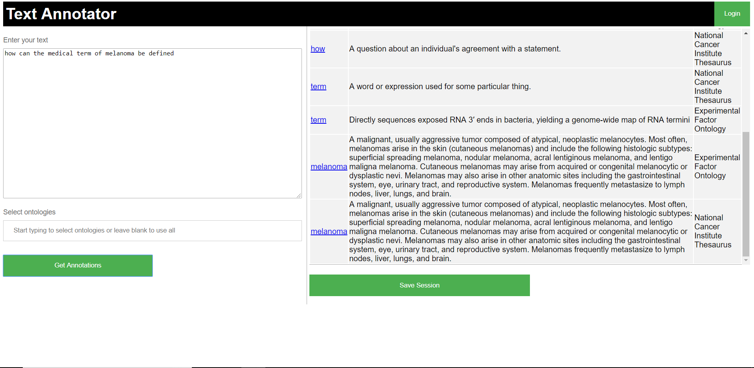

The following stop words are used by default:
I, a, above, after, against, all, alone, always, am, amount, an, and, any, are, around, as, at, back, be, before, behind, below, between, bill, both, bottom, by, call, can, co, con, de, detail, do, done, down, due, during, each, eg, eight, eleven, empty, ever, every, few, fill, find, fire, first, five, for, former, four, from, front, full, further, get, give, go, had, has, hasn’t, he, her, hers, him, his, i, ie, if, in, into, is, it, last, less, ltd, many, may, me, mill, mine, more, most, mostly, must, my, name, next, nine, no, none, nor, not, nothing, now, of, off, often, on, once, one, only, or, other, others, out, over, part, per, put, re, same, see, serious, several, she, show, side, since, six, so, some, sometimes, still, take, ten, the, then, third, this, thick, thin, three, through, to, together, top, toward, towards, twelve, two, un, under, until, up, upon, us, very, via, was, we, well, when, while, who, whole, will, with, within, without, you, yourself, yourselves

When we type a phrase that has many words(<15),the code will stop execution. The connected external library doesn’t allow to send more than 15 search word request per minute. The word that we are trying to search from the API call, cannot exceed the character length of 50. In which it results to error stating below

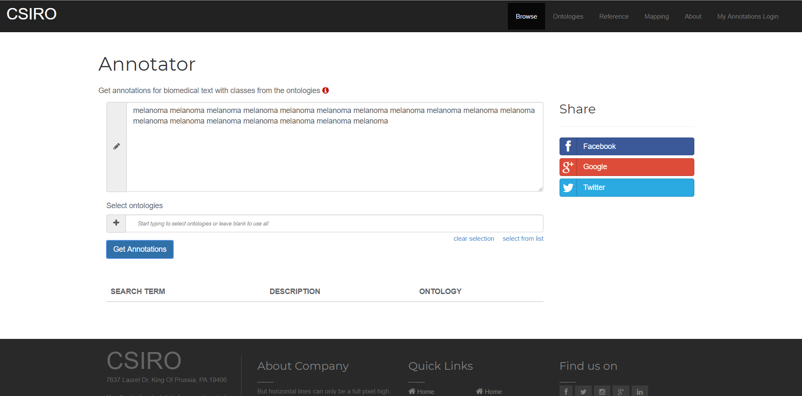

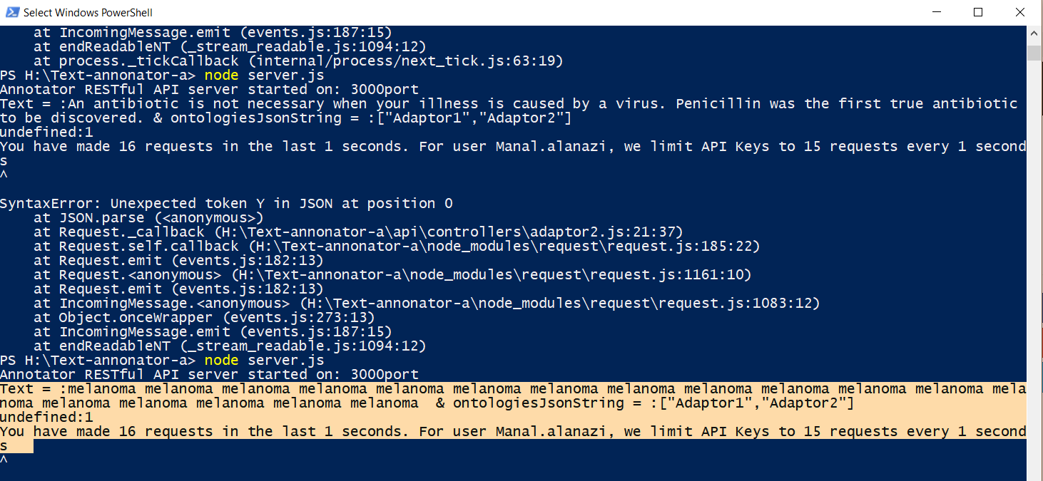

- Functional Characteristics of Annotator API:

Annotator.js file will be act as the API in this application which holds all the functions which is being used to accomplish the task of connecting external resources and find the explanations to the given text. Following are proposed functions of Annotator API.

checkOntologyConnection (URL, API KEY);
  - This function will be used to check the external vocabulary’s server status so that the GUI can show which Vocabularies are available to continue with the searching process.
  - This function accepts two arguments which are URL of the ontology (Vocabulary) and API KEY for the authentication purpose if it needs any.
  - Output of this function will be a Boolean which will be true if the connection successful or false if not.

getAllOntologyNames()
  - This function will be used to find all the ontology names in order to show them in the GUI.
  - Output of this function will be a name collection of saved ontologies.

getTextDefinitions (URL, API KEY, Text string, Ontologies, Match longest, Partial word matching, Include mapping, Exclude Numbers, Exclude Synonyms )
  - This function will be used to find the definitions of given texts from specified ontologies.
  - The arguments for this functions will be,
    - URl of the ontology
    - API KEY for authentication purposes
    - Text string of client’s search
    - Collection of client selected ontologies
    - Boolean value of match longest option
    - Boolean value of partial words match option
    - Boolean value of include mapping option
    - Boolean value of exclude numbers option
    - Boolean value of exclude synonyms option
  - Output of this function will be a JSON object which includes all the definitions for the given text string from specified vocabularies.

insertToDataBase(Collection name, Data)
  - This function will be used to store newly found results from a vocabulary search in the attached database.
  - This function accepts two arguments.
    - A name for the data collection to identifying purposes
    - Data that need to be stored. (JSON objects)
  - Output of this functions would be a success alert or an error.

updateFromDataBase(Collection name, currentValues, newValues)
  - This function will be used to update an existing data on the database.
  - This function accepts three arguments.
    - A name for the data collection to identifying purposes
    - Existing data that need to be updated.
    - New data that need to be saved instead.
  - Output of this functions would be a success alert or an error.

deleteFromDataBase(Collection name, Query Object)
  - This function will be used to delete an existing record/ object is the database.
  - This function accepts two arguments.
    - A name for the data collection to identifying purposes
    - Query object which defines the record to delete from database.
  - Output of this functions would be a success alert or an error.

searchFromDataBase(Collection name, Query Object)
  - This function will be used to find previously cached data from the database.
  - This function accepts two arguments.
    - A name for the data collection to identifying purposes
    - Query object which defines the record to search from database.
  - Output of this functions would be JSON object which consists of corresponding results.

getOntologyByID(Collection name, Query object)
  - This function will be used to find a stored ontology by its ID from the database.
  - This function accepts two arguments.
    - A name for the data collection to identifying purposes.
    - Query object which defines the record to search from database.
  - Output of this functions would be JSON object which consists of corresponding results.

disableExistingOntology(Collection name, Query object, currentValues, newValues)
  - This function will be used to disable an existing ontology from the database.
  - This function accepts four arguments.
    - A name for the data collection to identifying purposes
    - Query object which defines the record to search from database.
    - Existing data that need to be updated.
    - New data that need to be saved instead.
  - Output of this functions would be a success alert or an error.

enableExistingOntology(Collection name, Query object, currentValues, newValues)
  - This function will be used to enable an existing ontology from the database.
  - This function accepts four arguments.
    - A name for the data collection to identifying purposes
    - Query object which defines the record to search from database.
    - Existing data that need to be updated.
    - New data that need to be saved instead.
  - Output of this functions would be a success alert or an error.

Term Search
An endpoint for searching terms and their properties is available
- Perform search
  - GET POST /search?q={search query}
  - example: /search?q=melanoma
- Parameters
  - ontologies={ontology_id1,ontology_id2,ontology_id3}
  - require_exact_match={true|false} // default = false
  - suggest={true|false} // default = false. Will perform a search specifically geared towards type-ahead suggestions.
  - also_search_views={true|false} // Include ontology views in the search. default = false
  - require_definitions={true|false} // default = false
  - also_search_properties={true|false} // default = false
  - also_search_obsolete={true|false} // default = false (exclude obsolete terms)
  - cui={C0018787,C0225807,C0018787} // Allows restricting query by CUIs. default = null (no restriction)
  - semantic_types={T023,T185,T061} // Allows restricting query by Semantic Types (TUI). default = null (no restriction)
  - include={prefLabel, synonym, definition, notation, cui, semanticType} // default = (see Common Parameters section)
  - page={integer representing the page number} // default = 1
  - pagesize={integer representing the size of the returned page} // default = 50

Subtree Search
The same endpoint also allows limiting a search to a given subtree/branch. The root of the subtree is defined using a combination of parameters "ontology" and "subtree_root_id". Both are required when performing a subtree search.
- Perform a subtree search
  - example: search?q=melanoma&ontology=NCIT&subtree_root_id=http%3a%2f%2fncicb.nci.nih.gov%2fxml%2fowl%2fEVS%2fThesaurus.owl%23C3224
- Parameters
  - ontology={ontology_id}
  - subtree_root_id={a URI encoded class id of the root node of the subtree}

Ontology Property Search
An endpoint for searching ontology properties by their labels and IDs (URIs)
- Perform search
  - GET POST /property_search?q={search query}
  - example: /property_search?q=has dimension
- Parameters
  - ontologies={ontology_id1,ontology_id2,ontology_id3}
  - require_exact_match={true|false} // Restricts results only to the exact matches of the query by the property id, label, or the generated label (a label, auto-generated from the ID). default = false
  - also_search_views={true|false} // Include ontology views in the search. default = false
  - require_definitions={true|false} // Filter results only to those that include definitions. default = false
  - include={label, labelGenerated, definition, parents} // default = All of the properties in this example
  - ontology_types={ONTOLOGY,VALUE_SET_COLLECTION} // default = all ontology types are returned
  - property_types={object,annotation,datatype} // Restricts results to specific property types (object, annotation, datatype). default = all property types are returned

Annotator
The Annotator endpoint will examine text input and return relevant classes.
- Annotate text
  - GET POST /annotator?text={input text}
  - example: annotator?text=Melanoma+is+a+malignant+tumor+of+melanocytes+which+are+found+predominantly+in+skin+but+also+in+the+bowel+and+the+eye.

- Parameters
  - Filtering & query behavior
    - ontologies={ontology_id1, ontology_id2..,ontology_idN}
    - semantic_types={semType1, semType2..,semTypeN}
    - expand_semantic_types_hierarchy={true|false} // default = false. true means to use the semantic types passed in the "semantic_types" parameter as well as all their immediate children. false means to use ONLY the semantic types passed in the "semantic_types" parameter.
    - expand_class_hierarchy={true|false} // default = false. used only in conjunction with "class_hierarchy_max_level" parameter; determines whether or not to include ancestors of the given class when performing an annotation.
    - class_hierarchy_max_level={0..N} // default = 0. the depth of the hierarchy to use when performing an annotation.
    - expand mappings={true|false} // default = false. true means that the following manual mappings will be used in annotation: UMLS, REST, CUI, OBOXREF.
    - stop words={word1,word2..,wordN} (case insensitive)
    - minimum_match_length={0..N}
    - exclude_numbers={true|false} // default = false
    - whole_word_only={true|false} // default = true
    - exclude_synonyms={true|false} // default = false

